**NCR creation:**

**Form** [**location**](https://hpe.sharepoint.com/teams/ngitsupport/Lists/Network%20Connectivity%20Service%20Requests/Item/newifs.aspx)**:**

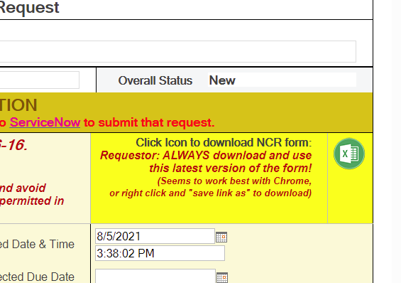

1. Download the from above location
2. Once opened, click enable editing and enable content.
3. In row 9 choose as seen below, it will create two new sheets

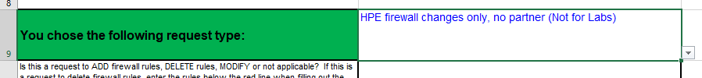

**NCR Form filling:**

Fill column A to L in NCR sheet, by referring to the data in NCS sheet. The fields Network component, IPs, App name, Protocol.

Only change after filling is if you find **HPE on HPE Chandler** as network compartment in NCS sheet, please choose **HoH - Chandler Cloud Zone** in NCR sheet. Similarly, if it is **HPE on HPE Carrollten,** choose **HoH - Carrollten Cloud Zone.**

Please combine all the NCS sheets in to a single NCR sheet in each folder. For example, in folder **ES_ECP_COLO2_ITG_PROD-DR** we have below 5 sheets, which can be combined in to a single NCR sheet

All the entries can be just added one after the other. This has to be done for **all the NCS folders** we created and available in this [location](https://hpe.sharepoint.com/:f:/s/CaaSDocs/EvqsW-D_82dPi5T11ZcBSy8B45VyRCIbMQ8sECqMlHAEZg?e=IiGjQY).

NCS:

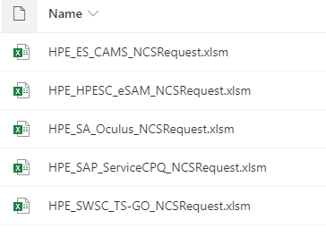

NCR:

